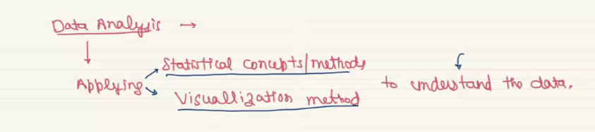

From that visulations we have to write our conclusion from the visual insights, its about converting the visualization to English word or sentence

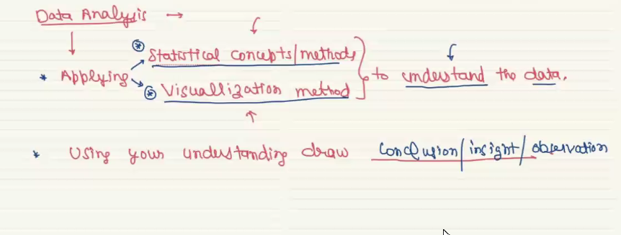

A **data-driven insight** in data science is a valuable understanding or decision derived directly from analyzing and interpreting data.

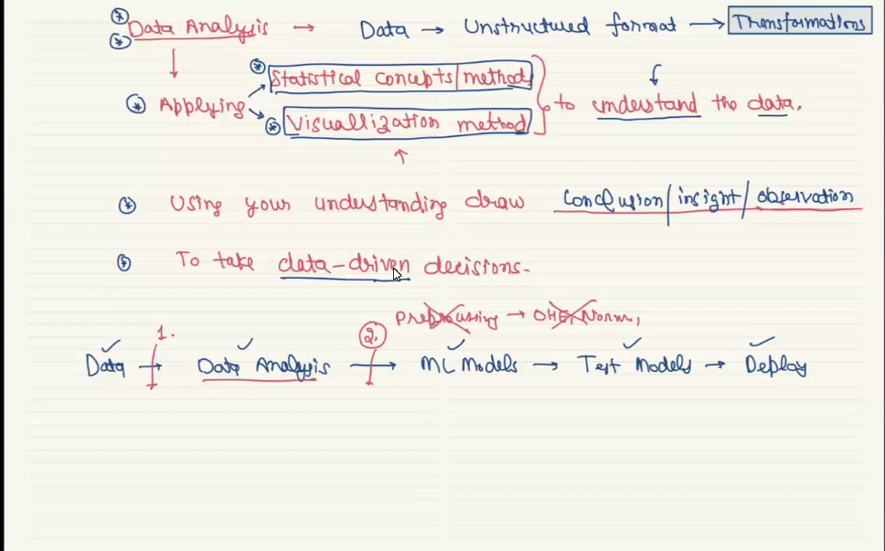

**Univariante analysis** – Make the analysis one only one column, numerical column or categorical column

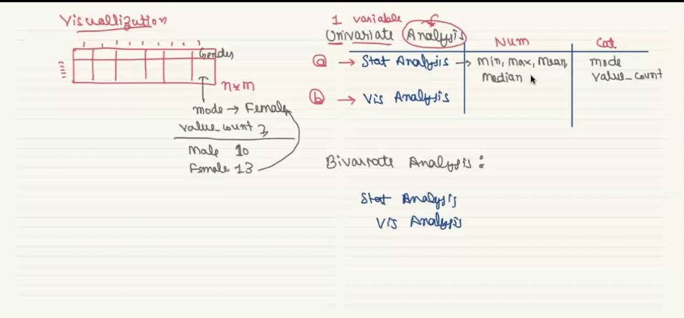

**Bivarante Analysis –** Make analysis on the combination of columsn, categorical and numerical

